**[IS113] Extra Exercises - Week 11 - Database Interaction**

**Objectives**

* To master the concepts of database interaction in PHP

**Instructions**

* Questions with no asterisk mark are easy peasy.
* Questions marked with * are slightly challenging.
* Questions marked with **\***\* are challenging.
* Questions marked with *** are very challenging.

**Download**

* **Resources**: Click [here](https://smu.sg/AY20-21-is113-extra-exercises-wk11-resource)

**NOTE:** If you spot any mistakes/errors in the questions, please contact your instructors by email and state the issues. We will try to address it as soon as possible.

**Database Connection (from inside PHP code)**

1. **WAMP Users**
   1. Upon WAMP installation, if you have not changed your MySQL login info will be:
      1. **Username**: root
      2. **Password**: <left empty>
2. **MAMP Users**
   1. For most students we have assisted, it appears that the default MySQL login info is:
      1. **Username**: root
      2. **Password**: root
   2. Additionally, your **MySQL port** appears to be **3306** (*please verify this on your own laptop computer and* ***remember to note it down***).
      1. You will have to specify **port** in **ConnectionManager.php**.
      2. Please remember to configure **ConnectionManager.php** on your own in all Extra Exercises as well as in Lab Test 2 questions **on your own** (as we instructional staff do NOT provide a separate **ConnectionManager.php** file for non-WAMP users).

**Question 1: Person Filter (*)**

**Given:**

* q1/model
  + ConnectionManager.php, Person.php (**complete**)
  + PersonDAO.php *(****partial****)*
* q1/
  + common.php (**complete**)
  + display.php *(****partial****)*
  + setup.sql (**complete**)

Read and use the given setup.sql to understand and create the necessary database and tables for this question.

**Part A: Complete search method of "PersonDAO.php"**

Complete **search** method of **PersonDAO.php** page to retrieve all persons from **person** table that satisfy the search criteria (minimum age, maximum age, and gender).Return all matching persons as an indexed array of **Person** objects. If Part A is completed well, the following would be the behavior when **display.php** is opened in the web browser:

*When the page loads for the first time:*

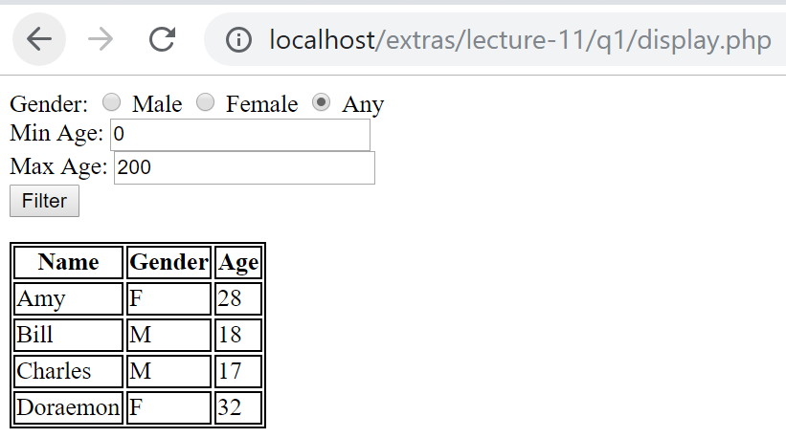

*When one or more search criteria are specified and* ***Filter*** *submit button is clicked:*

*(i) search criteria are specified*

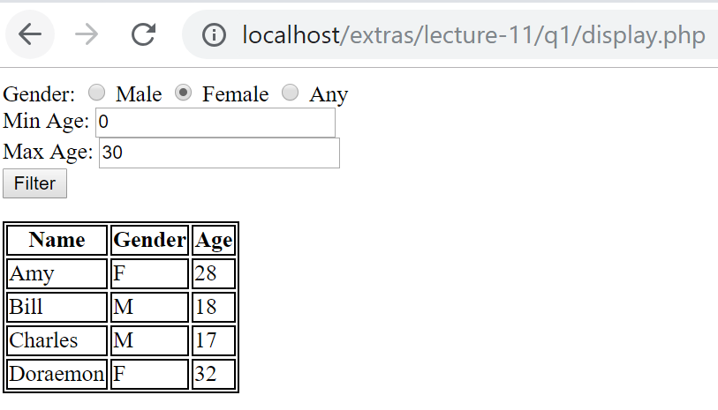

*(ii) output*

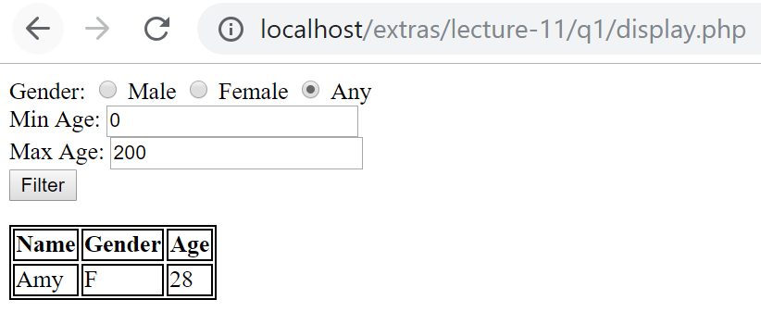

**Part B: Complete "display.php"**

Complete display.php so that the page remembers the values that the user selects before the **Filter** button is clicked. If Part B is completed well, the following would be the behavior when display.php is opened on the web browser:

*(i) search criteria are specified*



*(ii) output*

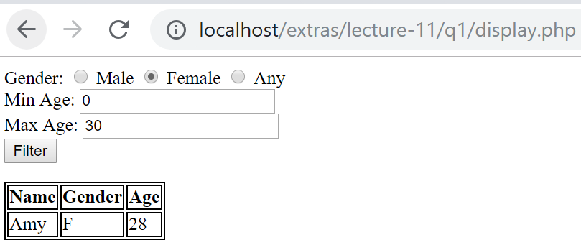

**Question 2: Warehouse (**)**

**Given:**

q2/

* create.sql
* style.css
* ConnectionManager.php, Product.php, Warehouse.php
* categoryList.php
* searchByCategoriesAndPriceRange.php
* searchByCategory.php
* searchByPriceRange.php
* testGetCategories.php
* testSearchByCategory.php
* testSearchByPriceRange.php

**[1]**Read and use the given **create.sql** to understand and create the necessary database and tables for this question.

**Part A**

Update class Warehouse to implement its method getCategories() to

1. Retrieve the list of product categories from database table category
2. Return the product categories as an indexed array of strings sorted alphabetically (case-sensitive) in ascending order

If done correctly, testGetCategories.php should display the following:

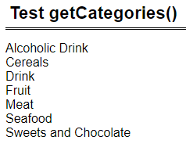

**Part B**

Create class Product

1. Four properties: Product name : String, Category name : String, Quantity : Integer, Price : Float
2. Constructor that takes in 4 parameters to initialize its properties.
3. Getter methods for its properties.

Update class Warehouse to implement its method searchByCategory($category_name) to

1. Parameter
   1. $category_name is the product category to search for
2. Return an indexed array of Product objects representing products for the specified category sorted by products' name alphabetically (case-sensitive) in ascending order.

If done correctly, testSearchByCategory.php should display the following: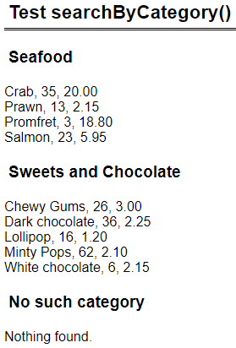

**Part C**

Edit searchByCategory.php such that it has a form with

1. A drop down list of product categories retrieved using class Warehouse’s method getCategories().
2. Button ‘Search’ that submits the form back to itself (same page) via HTTP GET.

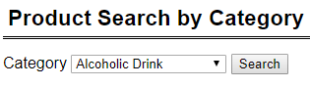

Upon form submission, the page does the following:

1. The drop down list should show the category that user has selected.
2. Retrieves all products of the specified category using class Warehouse’s method searchByCategory($category_name).
3. Display details of the products as shown in the table below sorted by products' name alphabetically (case-sensitive) in ascending order.
4. For quantity,
   1. If quantity is less than 10, display quantity in red.
   2. If quantity is less than 20, display quantity in orange.
   3. Otherwise, black.
   4. Look at the given searchByCategory.php for the CSS code for text color.

If done correctly, when user searches for category ‘Sweets and Chocolate’, the page should look like this:

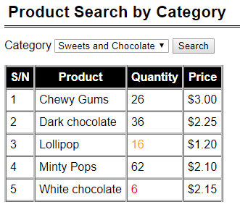

**Part D**

Update class Warehouse to implement its method searchByPriceRange($min_price, $max_price) to

1. Parameters
   1. $min_price (float) is the minimum price to search for
   2. $max_price (float) indicate the price range to search for.
2. You may assume that $min_price is less than or equal to $max_price.
3. Return an indexed array of Product objects whose price is between $min_price and $max_price inclusive. The products are sorted by **price, then product’s name** alphabetically (case-sensitive) in ascending order.

If done correctly, testSearchByPriceRange.php should display the following:

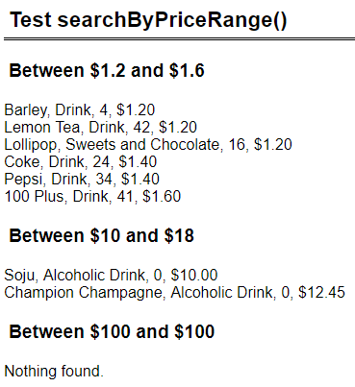

**Part E**

Edit searchByPriceRange.php such that it has a form with

1. Text field ‘Min price’ with default value 0.
2. Text field ‘Max price’ with default value 100.
3. Button ‘Search’ that submits the form back to itself (same page) via HTTP GET.

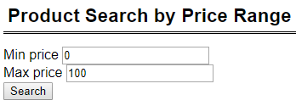

You may assume that user will always enter valid floating numbers for min and max prices, and min price is less than or equal to max price.

Upon form submission, the page does the following:

1. The two text fields should show the values that user has entered.
2. Retrieves all products whose price is between min and max prices inclusive.
3. Display details of the products as shown in the table below sorted by **price, then product’s name** alphabetically (case-sensitive) in ascending order.
4. Do the same color coding for quantity as part C.

If done correctly, when user searches for prices between 1.2 and 1.6 inclusive, the page should look like this:

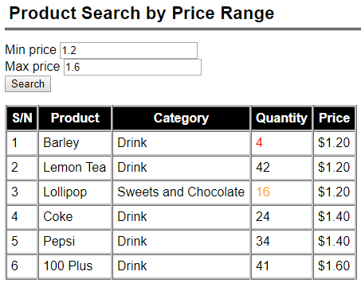

When user searches for prices between 1.2 and 1.6 inclusive, the page should look like this:

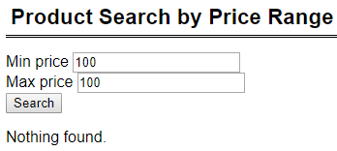

**Part F**

Update categoryList.php to display an ordered list of the product categories. Each category name is linked to searchByCategory.php. Upon clicking the category-name-hyperlink, searchByCategory.php should display the products for that category.

If done correctly, the page looks like this:

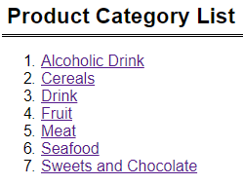

If user clicks on ‘Seafood’, the browser goes to searchByCategory.php (screenshot below) and displays ‘Seafood’ (as though user had selected ‘Seafood’ from the drop down list).

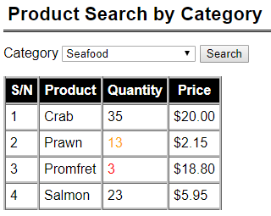

**Part G**

Update class Warehouse to implement its method searchByCategoriesAndPriceRange($category_name, $min_price, $max_price) to

1. Parameters
   1. $category_names is an indexed array of strings representing the categories to search for
   2. $min_price (float) is the minimum price to search for
   3. $max_price (float) indicate the price range to search for.
2. You may assume that $min_price is less than or equal to $max_price.
3. Return an **associative array.**
   1. Key is product category name
   2. Value is an indexed array of Product objects for the specified category and whose price is between $min_price and $max_price inclusive. The products are sorted by **category name then product's name** alphabetically (case-sensitive) in ascending order.

Edit searchByCategoriesAndPriceRange.php such that it has a form with

1. A list of checkboxes for the product categories.
2. Text field ‘Min price’ with default value 0.
3. Text field ‘Max price’ with default value 100.
4. Button ‘Search’ that submits the form back to itself (same page) via HTTP GET.

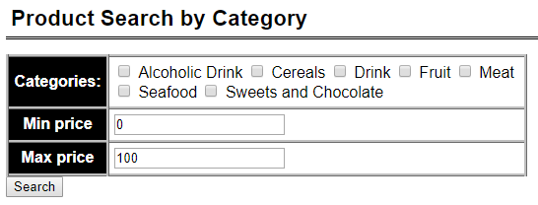

You may assume that user will always enter valid floating numbers for min and max prices, and min price is less than or equal to max price.

Upon form submission, the page does the following:

1. The form should show the values that user has selected or entered.
2. Retrieves all products for the specified category and whose price is between min and max prices inclusive.
3. Display details of the products as shown in the table below sorted by category name then product's namealphabetically (case-sensitive) in ascending order.
4. Do the same color coding for quantity as before.

If done correctly, sample screenshots of the page:

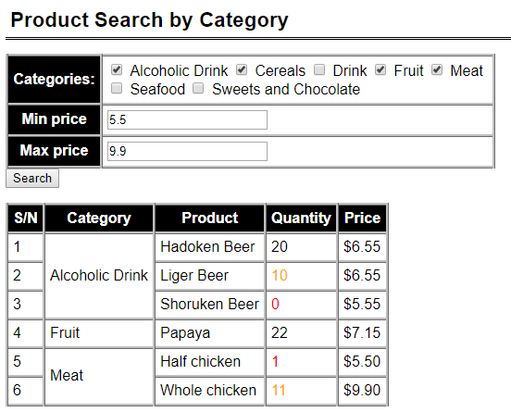

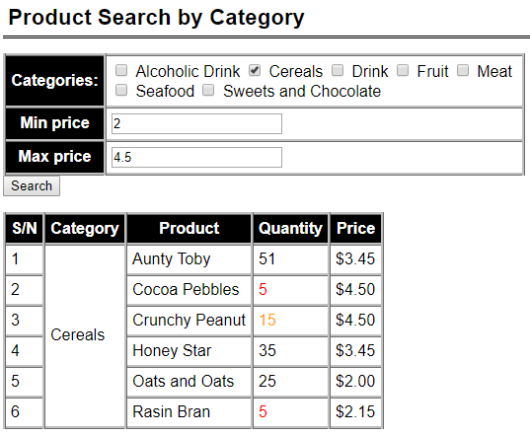

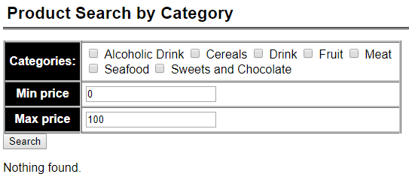

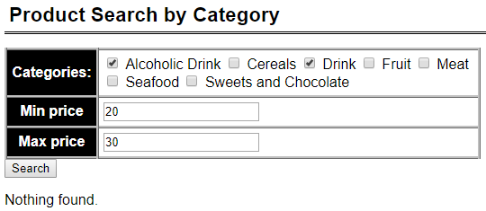

**Question 3: KPop Stars (**)**

**Given:**

q3/

* ConnectionManager.php, common.php, create.sql
* Star.php, StarDAO.php
* display.php, edit.php, update.php
* images/* (there are FOUR (4) JPG image files)

Read and use the given **create.sql** to understand and create the necessary database and tables for this question.

* Open create.sql. Take the SQL statements in this file and execute it (you may use **WorkBench** or **PHPMyAdmin**, whichever one you are comfortable with).
* It creates a schema **kpop**. Inside **kpop**, it creates a table **star**.

**Part A ( Difficulty: ** )**

Edit display.php such that it:

* Uses **StarDAO object** to query the database table **star** via public method **getAll()**, which returns an Indexed Array of **Star objects**.
* Receives an Indexed Array of **Star objects** and displays the stars’ information in an HTML table.

|  |
| --- |
| **display.php** |
|  |

The last table column **“Edit Link”** must display a HyperLink to page **edit.php**.

* The HyperLink URL will look like this: **edit.php?id=2**
* Clicking on this link will make a new HTTP GET request to **edit.php** with one parameter with the name **id**. The value (e.g. **2** in the above example) is a particular star’s **id** (as retrieved from the database). Your code can obtain this **id** from each **Star object** via public Getter method **getID()**.

**Part B ( Difficulty: ** )**

Suppose that the user clicks on **Seolhyun**’s **Edit** HyperLink. The user will be taken to **edit.php** with a particular **id**, e.g. **2** (this is the **ID** of **Seoulhyun** in my local MySQL database table **star**).

* Link: **edit.php?id=2**

Edit edit.php such that it:

* Retrieves the value of the parameter **id** from HTTP GET request.
* Takes this **id** value and calls **StarDAO** object’s public method **getStarByID($id)**. This method is defined in **StarDAO.php**. Please go and have a look at the method. ***What does it do?***
  + It retrieves a row from the database table **star** where the **id** column value matches that of the method parameter **$id**.
  + If a matching row is found in table **star**, this method retrieves all column data and create a new **Star** **object**. This **Star** **object** is then returned to **edit.php**.
* Takes the **Star** **object** and displays the star’s information as shown below:

|  |
| --- |
| **edit.php?id=2** |
|  |

* Only ONE (1) property (or attribute) is **editable**.
  + **Headline** text can be updated by the user.
* **Name** and **Gender** cannot be updated via this webpage. Hence, we display them as text (without editable input fields).
* Upon keying in new data for **Headline** input field (text), the user clicks on the SUBMIT button “Update Info”. It will then submit to **update.php** via HTTP POST method.
* Please see additional guiding comments inside **edit.php** for further instructions.

**Part C ( Difficulty: ** )**

*(Continuing with* ***Part B*** *example)*

Suppose that the same user clicks on “Update Info” SUBMIT button. It submits to **update.php**.

Edit update.php such that it:

* Retrieves the value of the parameter **id** AND the parameter **headline** from HTTP POST request.
* Calls **StarDAO** object’s public method **updateHeadline($id, $headline)**. This method is defined in **StarDAO.php**. Please go and have a look at the method. ***What does it do?***
  + It updates the table (**star**) **row** where the row’s **id** column value matches that of the method parameter **$id**. Specifically, it updates the value of the column **headline** in the matching row.
  + If the query executes successfully, then the method will return **Boolean True**.
  + Else, it will return **Boolean False**.
  + How do you check if **query** ran **successfully**?
    - See what **$stmt->execute()** returns. Does it return a Boolean value?

**BEFORE editing the “Headline” text**

|  |
| --- |
| **edit.php?id=2** |
|  |

**AFTER editing the “Headline” text**

|  |
| --- |
| **edit.php?id=2** |
|  |

**AFTER clicking on the “Update Info” SUBMIT button in edit.php**

|  |
| --- |
| **update.php** |
|  |

**AFTER clicking on the HyperLink** here

**display.php** shows the updated “Headline” text for Seolhyun (3rd row of the HTML table)

|  |
| --- |
| **display.php** |
|  |

**Question 4: Location and Store Filter (*)**

**Given:**

* q4/model
  + ConnectionManager.php, Product.php Shop.php (**complete**)
  + ProductDAO.php *(****partial****)*
  + ShopDAO.php *(****partial****)*
* q4/
  + common.php (**complete**)
  + display.php *(****partial****)*
  + setup.sql *(****run this before you start)***

The page allows the user to select a location and a shop name. These values are retrieved from the database and should not be hardcoded. The list of location and shop names are distinct, i.e. there should not be any duplicates. With these inputs, the application will proceed to check if the selected shop name exists at the selected location. If it does, it will return a list of products that are available by the shop. You can assume that a shop can exist in multiple locations, offering similar products. There are exceptional cases where the shop exists at the selected location but does not offer any products at this point of time.

**NOTE**: The suggested solution does not uses join tables in the SQL statements.

**Part A: Complete "ProductDAO.php and ShopDAO.php"**

Complete functions to retrieve the distinct list of locations, distinct list of shop names and list of products available at a shop. Return all matching data from ProductDAO.php as an indexed array of Product objects. The return of data from ShopDAO.php can be in the form of either an indexed array of Shop objects or strings.

**Part B: Complete "display.php"**

Complete display.php so that the page remembers the values that the user selects before the **Submit** button is clicked. If Part B is completed well, the following would be the behavior when display.php is opened on the web browser:

The following would be the behavior when display.php is opened in the web browser:

* *When the page loads for the first time, the distinct list of locations and shop names are provided in the drop down list. If nothing is selected, the default will be the first in the list:*

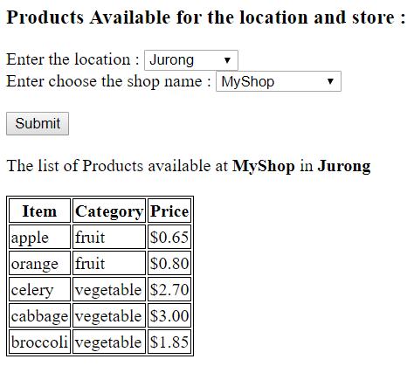

* *When the user selects a location and a shop name, the application will do a check. If the shop exists in the location but does not have any available products, the page will display the following:*

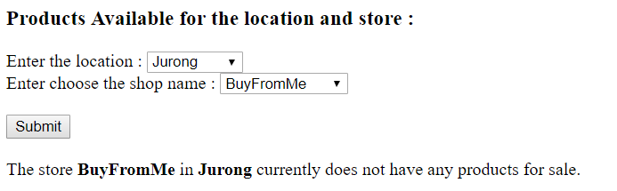

* *When the user selects a location and a shop name, the application will do a check. If the shop does not exist in the selected location, the page will display the following:*

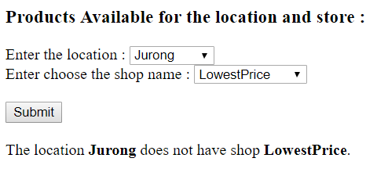

**Question 4b: Location and Store Filter Using Indexed Array within the Shop Class (**)**

**Copy the following files from Question 4 into the following drive:**

* q4/model
  + ConnectionManager.php (no changes required)
  + Product.php (no changes required)
  + ProductDAO.php (no changes required)
  + Shop.php (***changes required as below***)
  + ShopDAO.php *(may need modifications****)***
* q4/
  + common.php (no changes required)
  + display.php *(****changes required)***
  + setup.sql *(run this if you need to refresh your*

*database)*

In this version, the class Shop will have three properties – the shop name, the shop location and an indexed array of products sold by the shop. The indexed array will consist of Product objects which can be retrieved from the database by calling the ProductDAO class at the constructor. The modifications will be in the constructor.

The class Shop will looks like this:

|  |
| --- |
| class Shop{  private $name;  private $location;  private $items;  // this is an indexed array of Product objects.  public function __construct ($name, $location) {  $this->name = $name;  $this->location = $location;  // Use of ProductDAO to retrieve the list of products  // available at the store.  $dao = new ProductDAO();  ... /* enter your codes here */  }  } |

Make the appropriate modifications of the codes in Shop.php, ShopDAO.php and display.php such that it is able to make use of the updated class Shop. The codes in display.php will only need to call ShopDAO objects. The behavior of display.php is the same as Question 4.

**Question 5: Employment Statistics (**)**

**Given:**

q5/

● model/setup.sql **(complete)**

● model/populateDatabase.php **(complete)**

● model/ConnectionManager.php (**complete)**

● model/EmploymentStat.php ***(partial)***

● model/EmploymentStatDAO.php ***(partial)***

● common.php **(complete)**

● viewEmployment.php ***(partial)***

● updateEmployment.php ***(partial)***

● viewEmploymentB.php ***(partial)***

**Part A: Run populateDatabase.php**

Create week11extras database using setup.sql given.

Run populateDatabase.php from your localhost to create employmentstat table in week11extras database.

(note: populateDatabase.php accesses the statistics provided by [data.gov.sg](https://data.gov.sg/dataset/graduate-employment-survey-ntu-nus-sit-smu-suss-sutd) via an API and loads them into employmentstat table)

If done correctly, you should see some records in employmentstat table as follows:

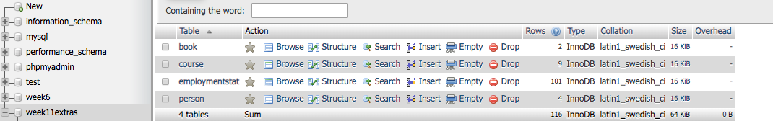

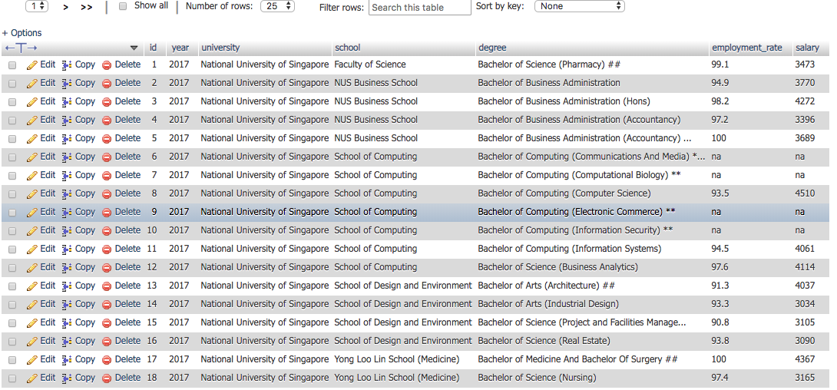

**Part B: Create class EmploymentStat**

1. Seven properties: id : Integer, year : Integer, university: String, school : String, degree : String, employment_rate : Float, avgSalary: Integer
2. Constructor that takes in 7 parameters to initialize its properties.
3. Getter methods for its properties.

**Part C: Complete retrieveAll method of EmploymentStatDAO.php**

Complete **retrieveAll** method of **EmploymentStatDAO.php** to retrieve all employment statistics from **employmentstat** table.Return the employment statistics data as an indexed array of **EmploymentStat** objects.

If done correctly, the following would be the behavior when **viewEmployment.php** is opened in the web browser:

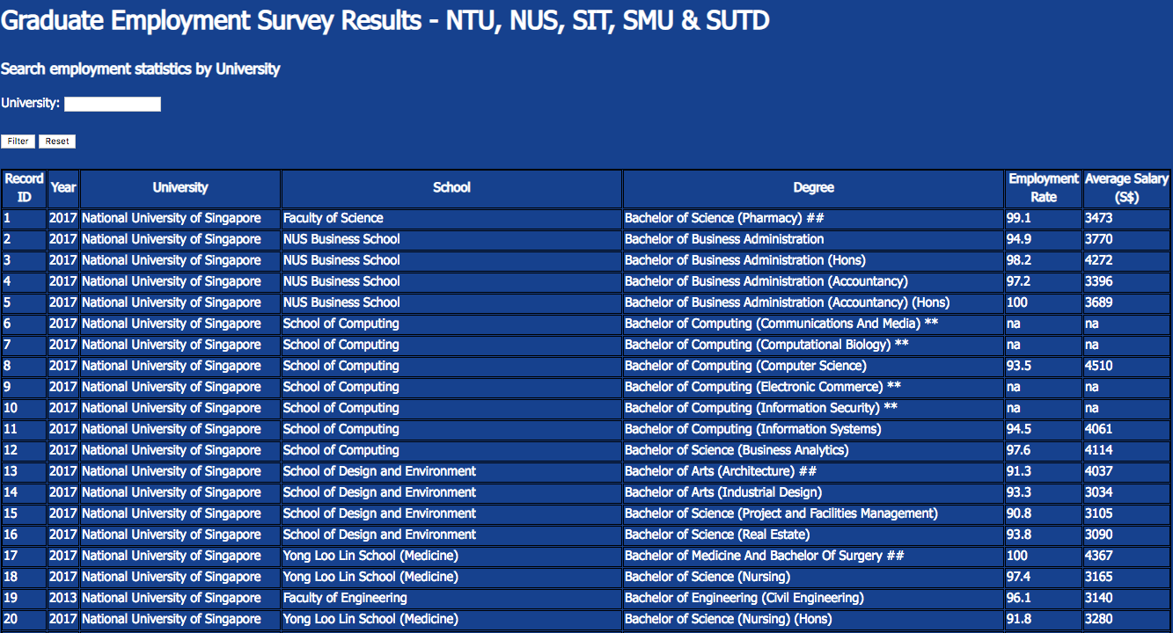

**Part D: Implement SearchByUniversity functionality**

1. Complete **searchByUniversity** method of **EmploymentStatDAO.php** to retrieve the employment statistics of **a given university** from **employmentstat** table.Return the employment statistics data as an indexed array of **EmploymentStat** objects.

2. Complete **viewEmployment.php** by adding code to read the **university** input from the user and retrieve the employment statistics of that university, by using the **searchByUniversity** method implemented above.

3. Upon clicking the **Filter** button in **viewEmployment.php**, it should display the employment statistics of a given university. Upon clicking the **Reset** button, it should display back all the employment statistics of all the universities.

Your code should handle possible exceptions and invalid scenarios, such as errors in accessing the database, clicking the Filter button without entering the university value, entering an invalid university value, etc.

If done correctly, the following would be the behavior when **viewEmployment.php** is run in the web browser:

*Entering the university input as “Singapore Management University”:*



*Upon clicking Filter button:*

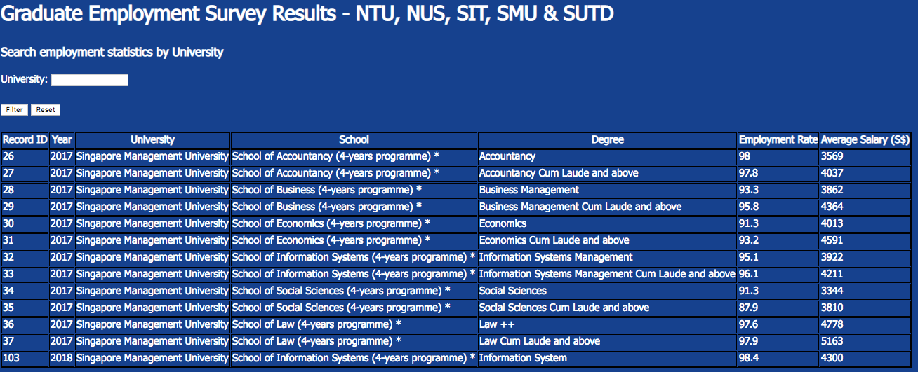

*Upon clicking Reset button:*



**Part E: Implement Create, Update, and Delete Employment Statistics functionality**

1. Complete **add** method of **EmploymentStatDAO.php** to insert a new employment statistics into the **employmentstat** table.Return the Boolean value “TRUE” if insert operation is successful.

2. Complete **update** method of **EmploymentStatDAO.php** to update the **employment_rate** and **salary** of an existing employment statistics record in the **employmentstat** table, given its **id**.Return the Boolean value “TRUE” if update operation is successful.

3. Complete **delete** method of **EmploymentStatDAO.php** to delete an existing employment statistics record in the **employmentstat** table, given its **id**.Return the Boolean value “TRUE” if update operation is successful.

Your code should handle possible exceptions and invalid scenarios, such as errors in accessing the database, entering invalid values, etc.

If done correctly, the following would be the behavior when **updateEmployment.php** is run in the web browser:

*Loading* **updateEmployment.php** *for the first time:*

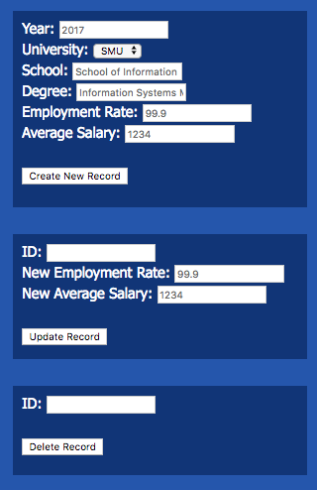

*Creating a new employment statistics: Upon clicking “Create New Record”:*

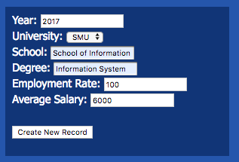 

*Updating an employment statistics: Upon clicking “Update Record”:*

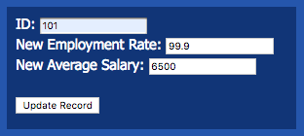 

*If create and update operations are successful, some changes should be observed in the employmentstat table in the database:*

*Deleting an existing employment statistics: Upon clicking “Delete Record”:*

* *

*In the employmentstat table in the database, record with id “101” should be deleted.*

**Part F: Implement computing average employment rate and salary of each university and each school**

1. Complete **viewEmploymentB.php** such that by default (when the page loads the first time or when the user clicks the **Reset** button), it displays the average salary and employment rate of each university.

2. Complete **viewEmploymentB.php** such that when the user provides a university input, it should display the average salary and employment rate of each school in that university.

If done correctly, the following would be the behavior when **viewEmploymentB.php** is run in the web browser:

*Loading* **viewEmploymentB.php** *for the first time:*



*Entering the university input as “Singapore Management University”:*



*Upon clicking the Filter button:*

**

*Upon clicking the Reset button:*

**

**Question 6: Maintain a Restaurant Menu (**)**

**Given:**

* q6/model
  + ConnectionManager.php, Food.php (**complete**)
  + FoodDAO.php *(****partial****)*
* q6/
  + common.php (**complete**)
  + maintain_menu.php (**partial**)
  + edit.php *(****partial****)*
  + delete.php *(****partial****)*
  + setup.sql *(****run this before you start)***

This exercise allows you to maintain the Food Menu at IS113 Kiosk. This application makes use of three php programs to provide an interface for the user to maintain the set of data in the database. The primary key for each food item is defined as the Stock-Keeping-Unit (SKU in short) of type integer. The use of an SKU will identify a unique record from the database. The database also keeps track of the description, category and price of the SKU.

**Part A: Complete "FoodDAO.php"**

Complete functions in FoodDAO.php to perform the following:

* retrieve all records of food items that are offered, sorted by SKU. The method will return an indexed array of Food objects.
* retrieve a single record identified by the SKU the user input. The method will return a Food object.
* update a single record in the database for the SKU selected by the user The method will return a status.
* delete a single record in the database for the SKU selected by the user The method will

**Part B: Complete "maintain_menu.php", “edit.php”, “delete.php”**

* *The maintain_menu.php will serve as the landing page of the application. There are two parts. At the top, it will display a snapshot of what are the food items available in the database, together with the description and prices. For each record, it will have a link should the user want to edit or delete the record.*
* *After that, there is an interface which will allow the user to create new food items.*
* *The following would be the behavior when maintain_menu.php is opened in the web browser:*

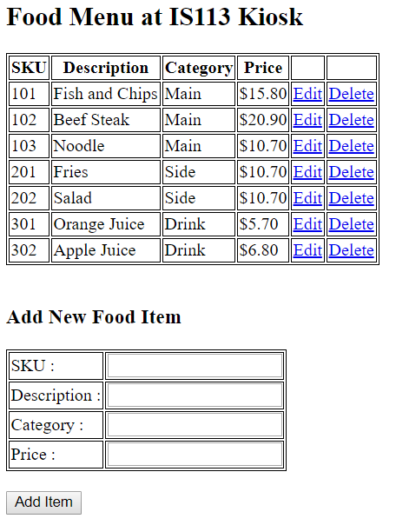

* *A user can add a new food item by keying in all the values and click on* ***Add Item****.*

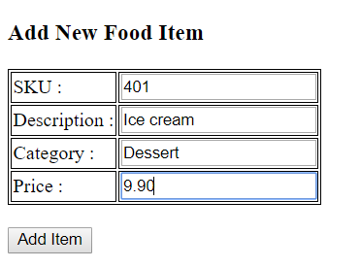

* *Upon successful creation of the new record. The menu is refreshed and the successful statement is provided. The*

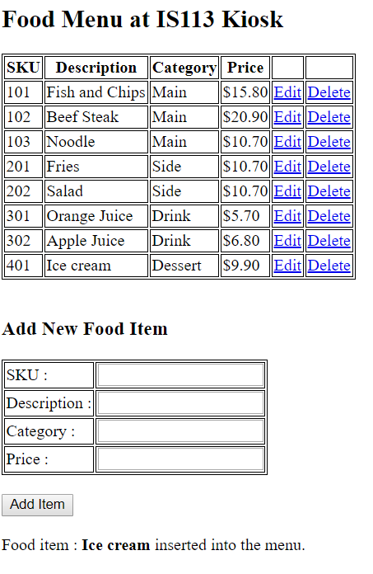

* *If the user enters a set of values but with the same SKU. The error message will be shown.*

*For example, if the user enters*

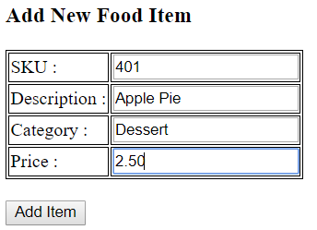

*Upon clicking Add Item, the screen will show*

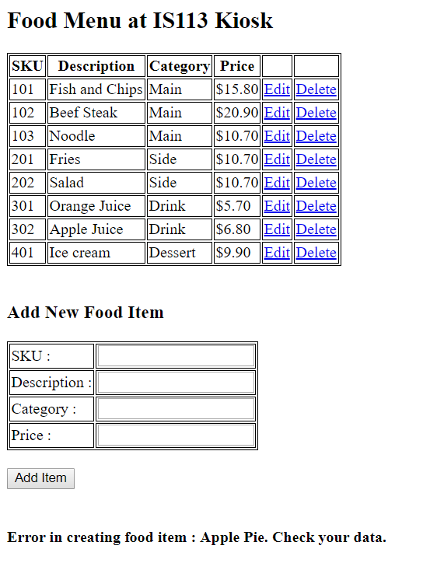

* *To edit a record, click on the Edit link. The following will be the display. The user will only be able to update the description, category and price. To complete the update, click on ‘Update Info’. A link is provided at the end of the page to return to the landing page.*

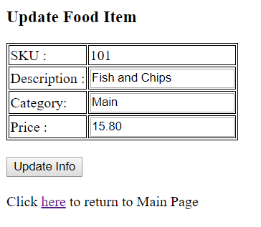

* *A successful update will show the following :*

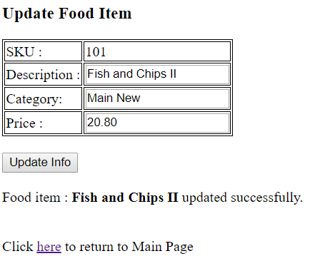

* *To delete a record, click on the Delete link from maintain_menu.php. The details of the item will be displayed. Click on Confirm to delete the item.*

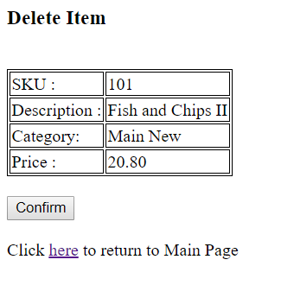

* *A successful delete will show the following :*

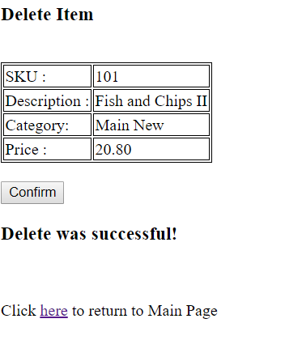

**Question 7: Blog Posts (**)**

**Given:**

* q7/database
  + create.sql
* q7/model
* ConnectionManager.php
* Post.php
* PostDAO.php
* q7/
* common.php
* add.html
* add.php
* delete.php
* edit.php
* update.php
* display.php

Read and use the given **create.sql** to understand and create the necessary database and tables for this question.

|  |
| --- |
| **create.sql** |
| ...  create table post (  id integer auto_increment primary key,  create_timestamp datetime,  update_timestamp datetime,  subject varchar(100),  entry text,  mood varchar(30)  );  ... |

* **id** is an internal (to MySQL database table post) ID
  + It is auto-generated and auto-incremented by the MySQL database.
  + Users or you (developer) do NOT need to manually add **id** data when insert new rows.
* **create_timestamp**
  + Indicates the datetime of data (row) insertion.
  + Any new blog posts being added to the **post** table via your web application will have **CURRENT_TIMESTAMP** as the default value. See **CURRENT_TIMESTAMP** below.
  + For more information, please check out: <https://www.w3schools.com/sql/func_mysql_current_timestamp.asp>
  + For example:

|  |
| --- |
| INSERT INTO post  (  create_timestamp,  update_timestamp,  subject,  entry,  mood  )  VALUES  (  **CURRENT_TIMESTAMP**,  **CURRENT_TIMESTAMP**,  'I hate school',  'I do not want to go to school',  'Sad'  ) |

* **update_timestamp**
  + Indicates the timestamp of data (row) update.
  + Any new blog posts being added to the **post** table via your web application will have **CURRENT_TIMESTAMP** as the default value. See **CURRENT_TIMESTAMP** above.
  + When a particular **post** is updated (e.g. subject/entry/mood change) via your web application, your code must also update **update_timestamp** by setting it to **CURRENT_TIMESTAMP**.
  + This way, we can capture in the MySQL database … when was the last time a particular **post** was updated.

**Part A ( Difficulty: ** )**

Edit **display.php** such that it:

* Uses **PostDAO object** to query the database table **post** via public method **getAll()**, which returns an Indexed Array of **Post objects**.
* Receives an Indexed Array of **Post objects** and displays the posts’ details in an HTML table.

|  |
| --- |
| **display.php** |
|  |

1. The table column **“Edit Link”** must display a HyperLink to page **edit.php**.
   1. The HyperLink URL will look like this: **edit.php?id=1**
   2. Clicking on this link will make a new HTTP GET request to **edit.php** with one parameter with the name **id**. The value (e.g. **1** in the above example) is a particular post’s **id** (as retrieved from the database). Your code can obtain this **id** from each **Post object** via public Getter method **getID()**.
2. The table column **“Delete Link”** must display a HyperLink to page **delete.php**.
   1. The HyperLink URL will look like this: **delete.php?id=1**
   2. Clicking on this link will make a new HTTP GET request to **delete.php** with one parameter with the name **id**. The value (e.g. **1** in the above example) is a particular post’s **id** (as retrieved from the database). Your code can obtain this **id** from each **Post object** via public Getter method **getID()**.
3. “**Add a New Blog Post**” at the bottom of the page is a HyperLink to page **add.html**.

**Part B ( Difficulty: ** ) EDIT**

In display.php, suppose that the user clicks on the **first post**’s **“Edit”** HyperLink.



The user is taken to **edit.php** with a particular **id**, e.g. **1** (this is the **ID** of the **first post** in my local MySQL database table **post**).

Edit edit.php such that it:

* Retrieves the value of the parameter **id** from HTTP GET request.
* Takes this **id** value and calls **PostDAO** object’s public method **get($id)**. This method is partially implemented in **PostDAO.php**.
  + **Complete this method** such that it retrieves a row from the database table **post** where the **id** column value matches that of the method parameter **$id**.
  + If a matching row is found in table **post**, this method retrieves all column data and create a new **Post** **object**. This **Post** **object** is then returned to **edit.php**.
* **edit.php** takes this **Post** **object** and displays the post’s details as shown below:

|  |
| --- |
| **edit.php?id=1** |
|  |

* The user should be able to key in new data for:
  + **subject**
  + **entry**
* The user should be able to select new **mood** (drop-down list).

Upon keying in or selecting new data:

* The user clicks on the SUBMIT button “Update Info”.
* The form will submit to **update.php** via HTTP POST method.

**Part C ( Difficulty: ** ) UPDATE**

*(Continuing with* ***Part B*** *example)*

Suppose that the same user clicks on “Update Info” SUBMIT button. It submits to **update.php**.

Edit update.php such that it:

* Retrieves the following from HTTP POST request.
  + **id**
  + **subject**
  + **entry**
  + **mood**
* Calls **PostDAO** object’s public method **update($id, $subject, $entry, $mood)**.
  + This method is defined in **PostDAO.php**. This method is partially implemented.
  + **Complete this method** such that:
    - It updates the table (**post**) **row** where the row’s **id** column value matches that of the method parameter **$id**. It must update **update_timestamp, subject, entry, mood**.
    - If the query executes successfully, then the method will return **Boolean True**.
    - Else, it will return **Boolean False**.
    - How do you check if **query** ran **successfully**?
      * See what **$stmt->execute()** returns. Does it return a Boolean value?
      * Query failed?
        + Try **var_dump**-ing **$stmt->errorinfo()** and see what it shows.

**BEFORE editing**

|  |
| --- |
| **edit.php?id=1** |
|  |

**AFTER editing the “subject” text and “entry” text**

|  |
| --- |
| **edit.php?id=1** |
|  |

**AFTER clicking on the “Update Info” SUBMIT button in edit.php**

|  |
| --- |
| **update.php** |
|  |

**AFTER clicking on the HyperLink** here

**display.php** shows the updated “Subject” text for the first post (1st row of the HTML table)

Do you also notice **“Last Update Timestamp”** reflects a new **timestamp**?

|  |
| --- |
| **display.php** |
|  |

Click on **Edit** HyperLink and let’s check to see if all details were updated correctly.

**edit.php** correctly displays all new data.

|  |
| --- |
| **edit.php?id=1** |
|  |

**Part D ( Difficulty: ** ) DELETE**

*Remember the guy that asked me out on Valentine’s Day?*

*DUH! He dumped me. So, I want to erase him from my blog FOREVER! -_-;*

In display.php, suppose that the user clicks on the **“Delete”** HyperLink.



The user is taken to **delete.php** with a particular **id**, e.g. **5** (this is the **ID** of the **last post** in my local MySQL database table **post**).

Edit delete.php such that it:

* Retrieves the value of the parameter **id** from HTTP GET request.
* Takes this **id** value and calls **PostDAO** object’s public method **get($id)**.
  + **You should have completed this method’s implementation in Part B**.
* **delete.php** takes the **Post** **object** returned by **get($id)**. It displays the post’s details as shown below:

|  |
| --- |
| **delete.php?id=5** |
|  |

* The user clicks on the SUBMIT button “Confirm Delete”.
* The form will submit to **delete.php** via HTTP POST method.
* The form has ONE (1) **hidden** input inside the FORM:

|  |
| --- |
| <input type='hidden' name='id' value='5'> |

* It is hidden - such that it does not display in the web browser.
  + *View Source will show the above HTML though.*
* Hidden input fields are submitted as part of form submission.

Upon “Confirm Delete”, the page displays:

|  |
| --- |
| **delete.php** |
|  |

So what’s going on in **delete.php**?

* It uses a **PostDAO** object to call its public method **delete($id)**. This method is partially implemented.
  + **Complete this method** such that it deletes a row from the database table **post** where the **id** column value matches that of the method parameter **$id**.
  + If the query executes successfully, then the method will return **Boolean True**.
  + Else, it will return **Boolean False**.
  + How do you check if **query** ran **successfully**?
    - See what **$stmt->execute()** returns. Does it return a Boolean value?
    - Query failed?
      * Try **var_dump**-ing **$stmt->errorinfo()** and see what it shows.
* Upon successful delete, display:
  + **Delete was successful**
* Upon unsuccessful delete, display:
  + **Delete was NOT successful**

Now, let’s go see if the old memory of the heartbreaker is really GONE!!!

|  |
| --- |
| **delete.php** |
|  |

Click on here HyperLink.

**display.php** no longer lists my stupid love blog post. :-(

The post (with ID 5) is gone from the database table **post** permanently.

|  |
| --- |
| **display.php** |
|  |

**Part E ( Difficulty: ** ) INSERT**

*I found a new eye candy. He is my new boyfriend. His name is Justin. I can’t wait to write about him!!!*

**

In display.php, suppose that the user clicks on the **“Add a New Blog Post”** HyperLink.

|  |
| --- |
| **display.php** |
|  |

The user is taken to **add.html** and fills out the form with new details.

|  |
| --- |
| **add.html** |
|  |

* The user clicks on the SUBMIT button “Submit New Post”.
* The form will submit to **add.php** via HTTP POST method.
* *Have a look at the HTML inside* ***add.html****. You will see some fun* ***JavaScript*** *script for form validation.*

So what’s going on in **add.php**?

* It uses a **PostDAO** object to call its public method **add($subject, $entry, $mood)**. This method is partially implemented.
  + **Complete this method** such that it **inserts a NEW ROW** into the database table **post**.
  + The SQL query string is provided for you inside the method.
  + If the query executes successfully, then the method will return **Boolean True**.
  + Else, it will return **Boolean False**.
  + How do you check if **query** ran **successfully**?
    - See what **$stmt->execute()** returns. Does it return a Boolean value?
    - Query failed?
      * Try **var_dump**-ing **$stmt->errorinfo()** and see what it shows.
* Upon successful insertion, display:
  + **Insertion was successful**
* Upon unsuccessful insertion, display:
  + **Insertion was NOT successful**

|  |
| --- |
| **add.php** |
|  |

Now, let’s go see if my new post about my new love Justin is listed!

Click on here HyperLink (above).

**display.php** shows the latest list of posts.

The new post has an auto-generated (by MySQL) ID of 6.

|  |
| --- |
| **display.php** |
|  |

Click on EditHyperLink (ID 6) and make sure that all post details are correctly displayed in **edit.php**.

**Question 8: Club (**)**

1. Use wad_club.sql to create the required database schema and tables
2. Take a look at all the given PHP files.
3. Implement the methods in PersonDAO.php and ClubDAO.php according to the comments in the files.
4. Edit index.php, view_club.php, add_members.php and add_members_process.php such that it works according to the page flows described below.

**Description of page flows:**

1. Upon first loading of index.php, it displays a table of all clubs’ details  
   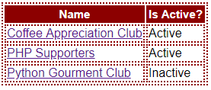
2. Click on a club’s name to go to view_club.php to view that club’s details. E.g. if user clicks on ‘Coffee Appreciation Club’, view_club.php will display:
   1. The club’s details in a table:
      1. Row 1 has a text field that has the club’s name by default.
      2. Row 2 has a checkbox. If the club is active, the checkbox is ticked. Otherwise, the checkbox is not ticked.
   2. ‘Save’ button.
   3. The names of the club’s members; one name per line. Clicking on a member’s name will tick its corresponding checkbox.
   4. ‘Remove selected members’ button.
   5. ‘Add members >>’ links to add_members.php.

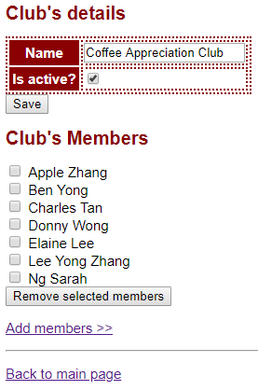

1. When he clicks the ‘Save’ button, the form is submitted back to view_club.php via HTTP POST.
2. If the submitted club’s name is empty or has only white spaces, display
   1. ‘Empty name’ and
   2. the club’s original details should be shown in the form.

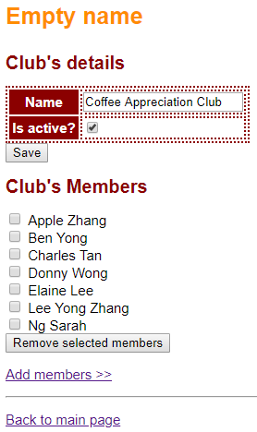

1. Otherwise, save the updated details for the club, display
   1. ‘Saved!’ and
   2. the club’s updated details should be shown in the form.  
      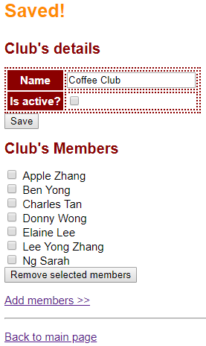
2. If user ticks one of more club’s members and click ‘Remove selected members’ button, remove the selected members and display ‘*member 1’s name*, *member 2’s name*, … removed!’.
   1. E.g. user selects ‘Ben Yong’ and ‘Donny Wong’ and submits the form.  
      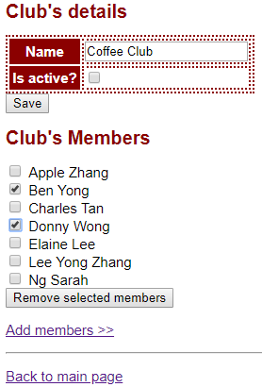
   2. The 2 members are gone from the list of members displayed. Message ‘Ben Yong, Donny Wong removed!’ is shown.  
      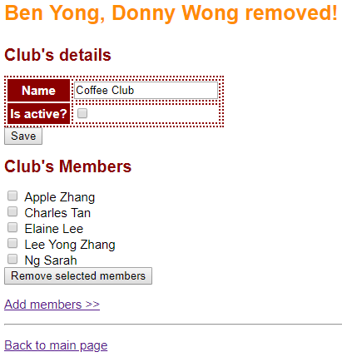
3. However, if user never select any member and clicks ‘Remove selected members’ button, display ‘No member selected’.

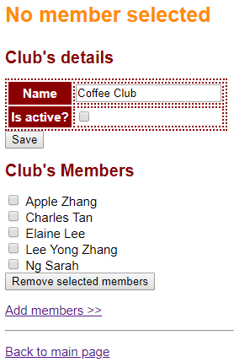

1. Click on link ‘Add members >>’ that links to add_members.php which allows user to add members to the club. Page add_members.php displays
   1. Heading 1 ‘*Club’s Name*: Add members’.
   2. ‘Back to club’ links back view_club.php to display the details of the club.
2. For inactive clubs (e.g. ‘Coffee Club’), page add_members.php displays ‘Can't add member to inactive club!’.  
   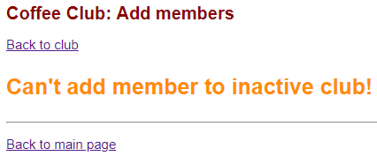
3. For active clubs (e.g. ‘PHP Supporters’), page add_members.php displays at ext field that allows user to specify a name and a ‘Search’ button.   
    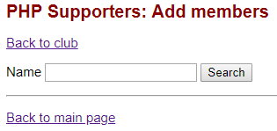
4. Click on ‘Search’ button submits the form back to add_members.php via HTTP GET. Page add_members.php displays
   1. An ordered list of persons’ names that contain the text specified by the user, ignoring case.
      1. A checkbox is displayed for those who are NOT members of the club.
      2. Clicking on the names in the search result will tick its corresponding checkbox.
   2. ‘Add members’ button  
      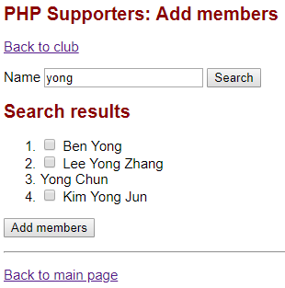
   3. If user leaves ‘Name’ text field empty, displays all persons (because all names contains the search string aka empty string).
   4. If there is no result (i.e. no one name contains the search string), display ‘No result found.’  
       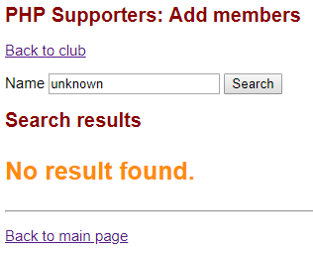
5. When user selects one or more person and clicks ‘Add members’ button, the form is submitted to add_members_process.php via HTTP POST.  
   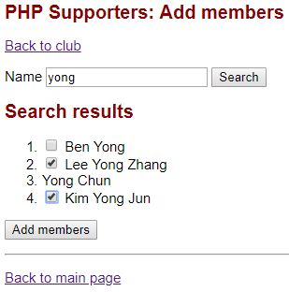
6. Page add_members_process.php adds the selected members to the club and displays
   1. Heading 1 ‘*Club’s Name*’.
   2. ‘Back to club’ links back view_club.php
   3. ‘Add more members’ links back add_members.php
   4. Display message ‘*member 1’s name, member 2’s name, ...* added!’.  
      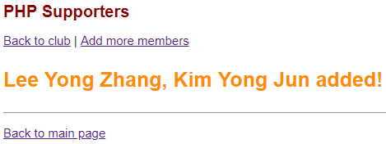
   5. If you click ‘Back to club’ , view_club.php should display the new added members. 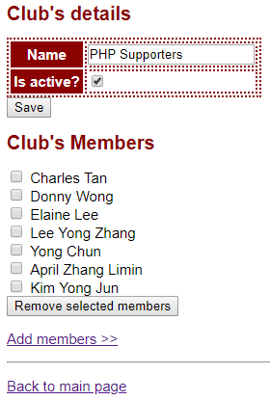
7. If user didn’t select any person and clicks ‘Add members’ button, add_members_process.php displays ‘No one selected’.  
   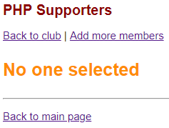

**Question 9 - Cat**

Go to **cat** directory**.** Complete the following **Parts A** and **B**.

In the last few weeks, we have been using **Associative Arrays** or **Indexed Arrays** to represent and store “things” such as persons, books, fruits, students, etc.

For example (see **data.php** file):

* **$cats** is an **Indexed Array** where each cat is represented and stored as an **Associative Array**.
  + The **key** is an **attribute** of a cat (e.g. name, age, gender, status).

|  |
| --- |
| **$cats** = [  // 1st cat  [  'name' => 'Dirty',  'age' => 12,  'gender' => 'M',  'status' => 'A'  ],  // 2nd cat  [  'name' => 'Filthy',  'age' => 7,  'gender' => 'F',  'status' => 'A'  ],  // 3rd cat  [  'name' => 'Boring',  'age' => 3,  'gender' => 'M',  'status' => 'A'  ]  ***// ... and so on***  ]; |

As shown above, we previously created new **cats** and stored them in an **Indexed Array**. Another way to **store** cat information is by using **Classes/Objects**.

**Part A (*)**

Complete **Cat.php** such that:

* **Cat** class defines what a cat should be. Every **Cat object** has the following FOUR (4) attributes:
  + **name** (e.g. 'Dirty')
  + **age** (e.g. 12)
  + **gender** (e.g. 'M' indicating ***male***, 'F' indicating ***female***)
  + **status** (e.g. 'A' indicating ***available***, 'P' indicating ***pending adoption***)
* Implement its constructor so that it takes in values for the FOUR (4) attributes
* Implement **Getter** methods for all of the attributes.

Great! Now that we have **Cat.php** that defines what every **cat** should look like, we can use this **definition** to create **new cats**!

|  |
| --- |
|  |

We declare a **DAO** (Data Access Object) **class** inside **CatDAO.php** file.

|  |
| --- |
| **CatDAO.php** |
| <?php  require_once 'Cat.php';  class CatDAO {  private **$cats**;  // constructor  public function __construct() {  **// Pre-populate static data**  **$this->cats** = [  new Cat('Dirty', 12, 'M', 'A'),  new Cat('Filthy', 7, 'F', 'A'),  new Cat('Boring', 3, 'M', 'A'),  new Cat('Needy', 3, 'M', 'P'),  new Cat('Lazy', 1, 'F', 'P')  ];  }  // whoever needs $cats, call this method off CatDAO object  **public function getCats() {**  **return $this->cats;**  **}**  }  ?> |

* **CatDAO** class’s constructor pre-populates **$cats** **Array** with FIVE (5) **Cat** objects.
* Via its **getCats()** public method, **CatDAO** class allows other PHP pages to access the **$cats** **Array**. For instance, later on, **display.php** will need to display all the **cats**.

**Part B (**)**

Complete **display.php** file. It must show all cats’ information as shown below:

|  |
| --- |
| **display.php** |
|  |

Where can **display.php** obtain the information about all the **cats**?

* From **CatDAO.php** file!!!
* It **requires** **CatDAO.php** file (e.g. **require_once**).
* It needs to **create a new CatDAO object**.
* Using this new **CatDAO object**, it can call all **public methods** of **CatDAO** class.
  + For now, we only have TWO (2) public method **getCats()** and the constructor.
  + The **getCats()** method will return an **Indexed Array** containing **Cat objects**.
* Can you now see how… the **concern of data retrieval** (**CatDAO.php**) is completely separated from **displaying of data** (**display.php**)?

|  |
| --- |
| **display.php** |
| <?php  **require_once 'CatDAO.php';**  **$dao = new CatDAO();**  **$cats** = $dao->getCats(); **// $cats is an Indexed Array of Cat objects**  ?>  <html>  <body>  <h1>Our Cats</h1>  <table border='1'>  <tr>  <th>Name</th>  <th>Age</th>  <th>Gender</th>  <th>Status</th>  </tr>  <?php  foreach(**$cats** as $cat_object) {  echo "  <tr>  <td>  **{$cat_object->getName()}**  ***... and more code below...*** |

**Question 10 - Cat2**

Go to **cat2** directory**.** Complete the following **Parts A** and **B**.

Copy the following files from **<web root>/is113/extra10/cat/** folder into the current folder **<web root>/is113/extra10/cat2/**.

* Cat.php
* CatDAO.php
* display.php

**Part A (**)**

Edit **CatDAO.php** file:

* Implement **getCatsByStatus($status)** public method.
* This method takes ONE (1) parameter, **$status**, where the valid values are:
  + 'A'
  + 'P'
* Given the parameter value of 'A', it is to:
  + Look for one or more **Cat** objects in **$cats** **Array** where each cat’s **status** is 'A'
  + Insert all matching **Cat** objects into an Indexed Array and return it.
* Likewise, for the parameter value of 'P', it is to perform the same but this time, the returned **Indexed Array** will contain all **Cat** objects where each cat’s **status** is 'P'.
* **Test Cases**
  + In your web browser, open **test.php**.
  + There are TWO (2) test cases inside.
  + Each test case must produce correct results. Verify that your new method returns the correct results.

**Part B (**)**

Edit **display.php** file.

When the page loads in a web browser **for the first time**, it must display display all cats.

|  |
| --- |
| **display.php** |
|  |

**Next**, when the user selects **Available** as the filtering value, and clicks on **Filter SUBMIT button**, the page displays:

|  |
| --- |
| **display.php** |
|  |

**NOTE:** The page must remember and pre-select the user’s form input **“Filter by Status”**. For instance, in the above example, “**Available**” option is pre-selected in the drop-down list.

**Next**, when the user selects **Pending Adoption** as the filtering value, and clicks on **Filter SUBMIT button**, the page displays:

|  |
| --- |
| **display.php** |
|  |

**NOTE:** The page must remember and pre-select the user’s form input **“Filter by Status”**. For instance, in the above example, “**Pending Adoption**” option is pre-selected in the drop-down list.

**Question 11 - Cat3**

Go to **cat3** directory**.** Complete the following **Parts A** and **B**.

Copy the following files from **<web root>/is113/extra10/cat2/** folder into the current folder **<web root>/is113/extra10/cat3/**.

* Cat.php
* display.php

I’m VERY SORRY to share with you... that our cat **Dirty** passed away last night... (a moment of silence please).



**Layfoo**, the adoption agency head, would like to request you (programmer) to **not display** Dirty’s information as he is no longer with us. So, what are you (programmer) now going to do?

* Go open up page **CatDAO.php**.
* Go into the **constructor** method.
* Manually remove the line of code creating a new **Cat object** corresponding to **Dirty**.

|  |
| --- |
| **CatDAO.php** |
| <?php  require_once 'Cat.php';  class CatDAO {  private $cats;  // constructor  public function __construct() {  // Pre-populate static data  $this->cats = [  **new Cat('Dirty', 12, 'M', 'A'), // remove this line... Dirty died**  new Cat('Filthy', 7, 'F', 'A'),  new Cat('Boring', 3, 'M', 'A'),  new Cat('Needy', 3, 'M', 'P'),  new Cat('Lazy', 1, 'F', 'P')  ];  } |

**WAIT A SECOND…**

1. What if there are **users** currently accessing my website? Will they get an error message WHILE I make this code fix?
2. What if **more cats die** in the coming weeks/months? Will I have to change my **code** AGAIN?
3. What if there are **more cats** coming into the agency? Will I have to change my **code** AGAIN?

|  |
| --- |
|  |

Wow! Our data are **static**! It’s **hard-coded**… INSIDE our code (**CatDAO.php**) OMG!!!

Honestly, I (programmer) don’t think I can afford taking my website down EVERY TIME … the data need to be updated. Especially given Layfoo’s testimonial:

* On average, 3-4 new cats are abandoned and dropped off at his agency office;
* On average, 1-2 cats die every week;
* On average, 2-3 new adoptions happen per month.

Now, we foresee… **frequent data updates**. Definitely, you won’t want to keep updating data **hard-coded** INSIDE your PHP code!

**So, how do we tackle this problem?**

|  |
| --- |
|  |

* Above, we completely separated out **data storage** away from PHP code.
* **Data Storage** is now handled exclusively by the **MySQL Database**.
* **CatDAO.php** now can focus on:
  1. **Interacting with the Database**
     + Create (C)
     + Read (R)
     + Update (U)
     + Delete (D)
  2. Store retrieved data (from MySQL Database) into **variables** (e.g. Class objects) so that **other PHP files** can access the data and display, etc.

**Part A (Creating a Database)**

Agency Head Layfoo populates the MySQL database, and he will now maintain the database. you (programmer) do NOT have to worry about updating the data at all.

* During the software (web app) development, you NEVER have your code interact with the **production Database**. What if you make mistakes in your code… that **wipes out** the data in the **production Database**? → DIE ALREADY!!!
* Hence, typically, software developers will **create a replica of the production Database** (if it’s too large, then take a subset of it) in their **local development/testing environment**.

Since you’re still developing this website for the Cat Adoption Agency… you will have to create a replica of Layfoo’s MySQL database… locally on your computer.

1. In your web browser, go to: [**http://localhost/phpmyadmin/**](http://localhost/phpmyadmin/)
   1. Alternatively, you can go to **WAMP icon** and **LEFT-CLICK** on the icon.

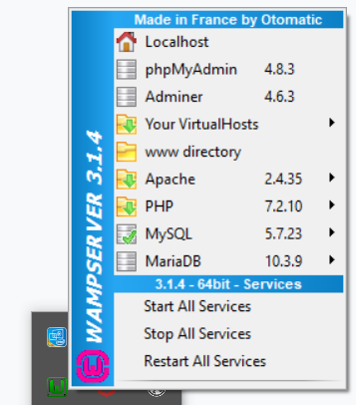

* 1. AND click on **phpMyAdmin**. It will pop up a web browser tab/window with the same URL **http://localhost/phpmyadmin**.
  2. If you are using MAMP or something else other than WAMP (or if you have changed WAMP’s configuration), then the URL will be different.

1. Sign in with:
   1. Username: **root**
   2. Password: <leave it empty> or something else depending on your setting
2. Click on **SQL** link at the top menu bar:

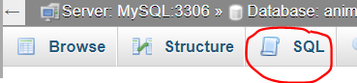

1. Open the file **create.sql**. Layfoo provided his MySQL database ‘animals’ **dump** in this SQL file. Copy the entire content and paste it into **PHPMyAdmin** SQL pane.

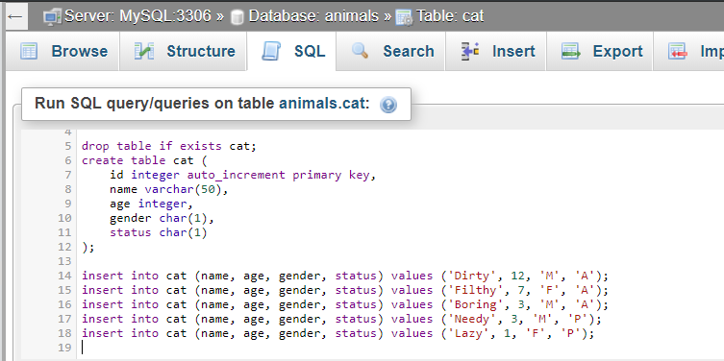

1. Click on **Go** button. The queries will be executed.
2. On the **LEFT SIDE** of the window, expand **animals** database and you should see a new table **cat**.

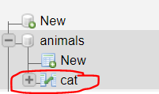

1. Click on **cat** table. You should see FIVE (5) rows of data inside:

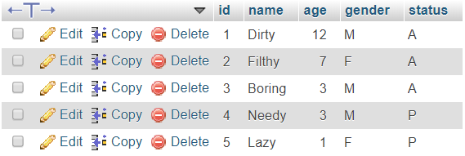

Our **Database** is now ready!

NOW, we have to find a way to CONNECT to it.

**Part B (Connecting to Database)**

Open **CatDAO.php**. This new **CatDAO** is very similar to the previous **CatDAO**. Both make available these two **public methods** for OTHER PHP files to call:

* getCats()
* getCatsByStatus($status)

Both methods return exactly the same things (Indexed Array of Cat objects). Hence, the same **display.php** file should work without any coding changes.

But there ARE some changes. Let’s have a look.

**Connecting to Database**

**CatDAO.php** requires another file **ConnectionManager.php**.

|  |
| --- |
| **ConnectionManager.php** |
| <?php  class ConnectionManager {  **public function connect()** {  $servername = 'localhost';  $username = 'root';  $password = '';  $dbname = 'animals';    // Create connection  $conn = new PDO("mysql:host=$servername;dbname=$dbname", $username, $password);  $conn->setAttribute(PDO::ATTR_ERRMODE, PDO::ERRMODE_EXCEPTION); // if fail, exception will be thrown  // Return connection object  return $conn;  }  } |

**ConnectionManager.php** handles **Database Connection** via PHP’s **PDO** (PHP Data Object) **extension**.

→ You do NOT need to know the details of **PDO** implementation.

→ You DO need to know how to **configure** the following in **ConnectionManager.php**:

* Server/Host name (e.g. **localhost**)
* Username: **Your DB username** (“root” by default)
* Password: **Your DB password** (empty by default)
* DB (instance) name (e.g. In our exercise, it is **animals**)

→ You do NOT need to memorize the code. But you are expected to know how to configure the above.

To use this from another PHP file, we must do the following:

* Import **ConnectionManager.php** file (e.g. **require_once**).
* Create a new **ConnectionManager** object.
* Off that object, call the public method **connect()**.
* This **connect()** method will make a connection to the specified Database and **return a PDO object** **$conn**.
* We can then use this object **$conn** to perform SQL operations (SELECT, INSERT, UPDATE, etc.).

**Part C (Retrieving Data from Database)**

Let’s revisit **CatDAO.php**. It provides two **public methods** for OTHER PHP files to call:

* getCats()
* getCatsByStatus($status)

The same **display.php** file from **Question 2** should work without any modification.

Let’s have a look at getCats(). It consists of SIX (6) steps. In Step 6, it returns an Indexed Array of Cat objects (if any matching rows were found in the database table **cat**).

|  |
| --- |
| **CatDAO.php | Method getCats()** |
| public function getCats() {    **// STEP 1**  **// Connect to database 'animals'**  // See 'ConnectionManager.php'  $connMgr = new ConnectionManager();  $conn = $connMgr->connect();  **// STEP 2**  **// Prepare SQL statement**  $sql = "**SELECT name, age, gender, status FROM cat**";  $stmt = $conn->prepare($sql);  **// STEP 3**  **// Run SQL**  $stmt->execute();  $stmt->setFetchMode(PDO::FETCH_ASSOC);  // Retrieve each row as an Associative Array  **// STEP 4**  **// Retrieve query results - ONE ROW AT A TIME**  **$cats = [];**  // Initialize an empty (indexed) Array  // so I can return it to whoever called this function  // Use WHILE loop to loop through  **while** ($row = **$stmt->fetch()** ) {  $cat = **new Cat(**  **$row['name'],**  **$row['age'],**  **$row['gender'],**  **$row['status']**  **)**;  **$cats[] = $cat;**  }    **// STEP 5**  **// Close DB Connection & SQL Statement**  $stmt = null;  $conn = null;  **// STEP 6**  **// YAY! We're ready to return the array!**  return $cats;  } |

Let’s have a look at getCatsByStatus($status). It consists of SIX (6) steps. In Step 6, it returns an Indexed Array of Cat objects **whose ‘status’** is equal to the **parameter** **$status**.

|  |
| --- |
| **CatDAO.php | Method getCatsByStatus($status)** |
| public function getCatsByStatus(**$status**) {  // $status == 'A' or 'P'  **// STEP 1**  // Connect to database 'animals'  // See 'ConnectionManager.php'  $connMgr = new ConnectionManager();  $conn = $connMgr->connect();  **// STEP 2**  // Prepare SQL statement  $sql = "**SELECT name, age, gender, status**  **FROM cat**  **WHERE status = :status** ";  $stmt = $conn->prepare($sql);  **// Parameter binding**  **$stmt->bindParam(':status', $status, PDO::PARAM_STR);**  // It **binds** the value of **parameter $status** to **:status** in the **SQL statement**.  **// STEP 3**  // Run SQL  $stmt->execute();  $stmt->setFetchMode(PDO::FETCH_ASSOC);  // Retrieve each row as an Associative Array  **// STEP 4**  // Retrieve query results - ONE ROW AT A TIME  $cats = [];  // Initialize an empty (indexed) Array  // so I can return it to whoever called this function  // Use WHILE loop to loop through  while ($row = $stmt->fetch() ) {  $cat = new Cat(  $row['name'],  $row['age'],  $row['gender'],  $row['status']  );  $cats[] = $cat;  }    **// STEP 5**  // Close DB Connection & SQL Statement  $stmt = null;  $conn = null;  **// STEP 6**  // YAY! We're ready to return the array!  return $cats;  } |

**Part D (Display Cat Information)**

In web browser, open **display.php** (you should have copied this file from **cat2** folder into **cat3** folder).

* You do NOT need to make any changes to **display.php**.
* The details of **CatDAO.php** is well-hidden from **display.php**.
* **display.php** does NOT need to know that **CatDAO** now retrieves data from **MySQL Database**.
* All **display.php** needs to know is … what are the public **methods** it can call - in order to retrieve needed data.
* **CatDAO** provides two **public methods** that **display.php** can call:
  + getCats()
  + getCatsByStatus($status)

When the page loads in a web browser **for the first time**, it must display display all cats.

|  |
| --- |
| **display.php** |
|  |

**Next**, when the user selects **Available** as the filtering value, and clicks on **Filter SUBMIT button**, the page displays:

|  |
| --- |
| **display.php** |
|  |

**NOTE:** The page must remember and pre-select the user’s form input **“Filter by Status”**. For instance, in the above example, “**Available**” option is pre-selected in the drop-down list.

**Next**, when the user selects **Pending Adoption** as the filtering value, and clicks on **Filter SUBMIT button**, the page displays:

|  |
| --- |
| **display.php** |
|  |

**NOTE:** The page must remember and pre-select the user’s form input **“Filter by Status”**. For instance, in the above example, “**Pending Adoption**” option is pre-selected in the drop-down list.

1. This question includes some CSS to make the web page looks nicer and spice things up. CSS is not within the assessment scope of this course. If you wish to learn more about CSS, go to <https://www.w3schools.com/css/>.